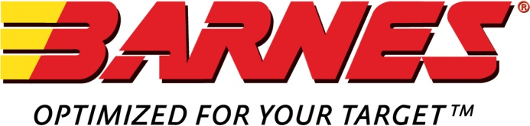  
  
  
Press Release

**Barnes Introduces New VOR-TX® Euro Line for 2016**

Mona, UT – Barnes Bullets, LLC (“Barnes”), the leader in bullet innovation and performance, introduces VOR-TX EURO Ammunition for the discriminating hunter in the European market.

VOR-TX EURO is precision loaded with the venerable Barnes all-copper, lead-free bullets and conforms to CIP pressure standards. This ensures safe operation and maximum ballistics potential while offering European hunters the best accuracy and terminal performance that surpasses lead-core bullets on both thin-skinned and heavy game. Drop game in their tracks instantly with VOR-TX EURO Ammunition by Barnes ̶ the leader in lead-free bullet technology.

The VOR-TX EURO line will available in the following calibers and bullet weights:

* 7 x 64 Brenneke 145 grain LRX BT
* 8 x 57 IS 160 grain TTSX
* 9.3 x 62mm 250 grain TTSX
* 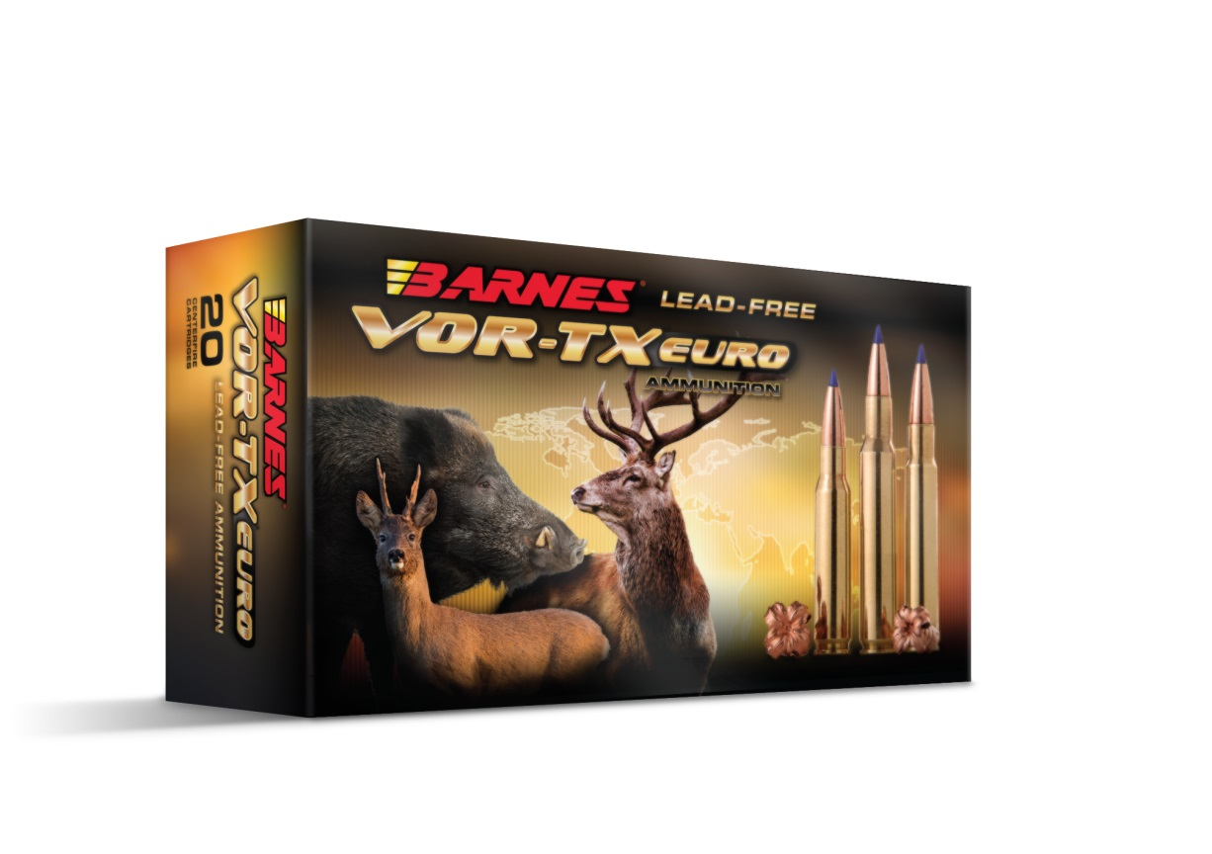30-06 SPRG 150 grain TTSX
* 30-06 SPRG 168 grain TTSX
* 30-06 SPRG 180 grain TTSX
* 308 WIN 130 grain TTSX
* 308 WIN 150 grain TTSX
* 308 WIN 168 grain TTSX

###

***About Barnes Bullets, LLC***

Barnes Ammunition products are purpose-built for precision shooters, America’s military elite and top-tier law enforcement communities. For the discriminating shooter who demands products that are uncompromising in performance and quality, we bring our relentless pursuit of innovative design, exacting manufacturing, and leading-edge testing capabilities. Visit www.barnesbullets.com for more information. Follow Barnes via [Facebook](https://www.facebook.com/barnesbullets) • [Blog](http://www.barnesbullets.com/blog/)