Nosler® Announces Expansion of BT® Ammunition for America’s Most Popular Game

Bend, Ore. – January, 2016 – For decades, Nosler’s Ballistic Tip® Hunting bullets have been extremely popular among America’s deer, antelope and hog hunters. That is why it makes perfect sense for Nosler®, Inc. to be expanding their line of BT® Ammunition, loaded exclusively with Ballistic Tip® Hunting bullets.

Offered in popular hunting cartridges with bullet weights and muzzle velocities that are optimized for maximum effectiveness on deer, antelope and hogs, Nosler® BT® Ammunition delivers the accuracy, flat trajectory, and reliable terminal performance hunters of these species require.

The Ballistic Tip® Hunting bullet line delivers excellent accuracy with sleek aerodynamic profiles combined with devastating terminal ballistics. Constructed with Nosler’s exclusive impact-extruded, tapered jacket, the Ballistic Tip® bullet provides controlled expansion and reliable performance on medium sized game across a broad impact velocity range of 1800-3200 fps.

Ballistic Tip’s legendary bullet performance, Nosler’s high quality ammunition standards, and a reasonable price marks Nosler Ballistic Tip Ammunition an ideal choice for hunters.

BT® Hunting Ammunition is available for purchase at Nosler dealers worldwide.
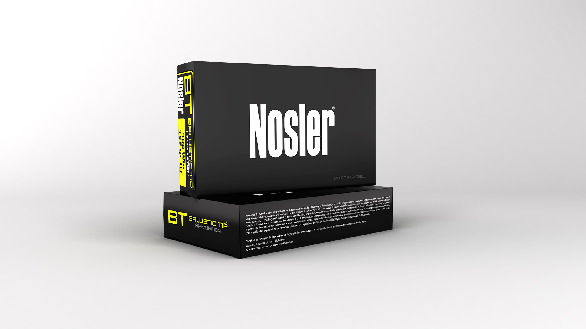
New for 2016
6.5 Creedmoor - 140gr. Ballistic Tip®
260 Remington - 120gr. Ballistic Tip®
7mm-08 Remington - 140gr. Ballistic Tip®

For the most current information on Nosler product announcements, visit Nosler’s Facebook page at www.facebook.com/NoslerInc
-###-

Media Contact:
Zach Waterman
Public Relations Manager
zachw@nosler.com

