NOSLER® BROADENS BALLISTIC TIP® LEAD FREE LINE

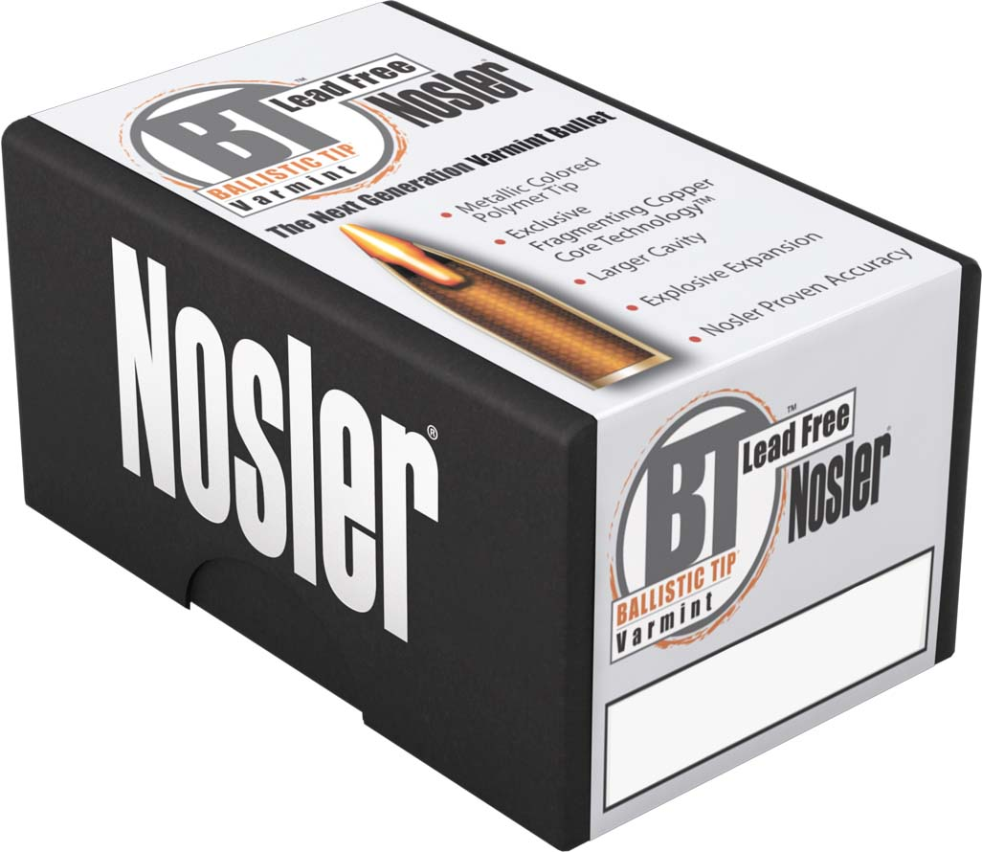
Bend, Ore — New for 2016, Nosler® has added the 22 caliber, 50 grain Ballistic Tip® Lead Free bullet to add to the existing 35 grain and 40 grain weight options in that caliber. Consumer demand vied for a heavier option in this highly frangible varmint and predator bullet that also offers the benefits of a higher ballistic coefficient and less sensitivity to wind drift.

The Ballistic Tip® Lead Free has a flat base with a metallic colored, polymer tip. The leadless bullet features Nosler’s exclusive Fragmenting Copper Core Technology™ which exhibits immediate and rapid expansion at practical varmint shooting velocities of 1600 fps and above.

The Nosler Ballistic Tip® Lead Free can safely be used within lead free zones or shooting ranges that require non-magnetic bullets. Users can be confident of the same performance and quality that the Ballistic Tip® has made famous for over 30 years.

For the most current information on Nosler® product announcements, visit Nosler’s Facebook page at www.facebook.com/NoslerInc

-###-

Media Contact:
Zach Waterman
Public Relations Manager
zachw@nosler.com

