NEW E-TIP® AMMUNITION LINE FROM NOSLER® PROVIDES HUNTERS AND SHOOTERS WITH A PREMIUM LEAD FREE OPTION

Bend, Ore. – January, 2016 – Nosler® created the E-Tip® Ammunition line to offer an affordable, lead-free ammunition alternative for hunters who are either required or choose to use a lead-free bullet. The advantages of the E-Tip® bullet are not limited to the material from which it is made however, its construction is what gives the E-Tip® its greatest advantage; high weight retention.

Because the E-Tip® retains so much weight, it provides extremely deep penetration and consistently straight wound channels. The E-Tip® smashes through heavy bone and muscle, typically performing like a much heavier bonded or lead-cored bullet. This high degree of penetration provides a significant advantage when hunting large game with non-magnum calibers. Offered in a variety of traditional American hunting cartridges, E-Tip® ammunition is an excellent choice for any North American big game or African plains game.

Initial offerings in Nosler’s E-Tip® line of ammunition for 2016 include:
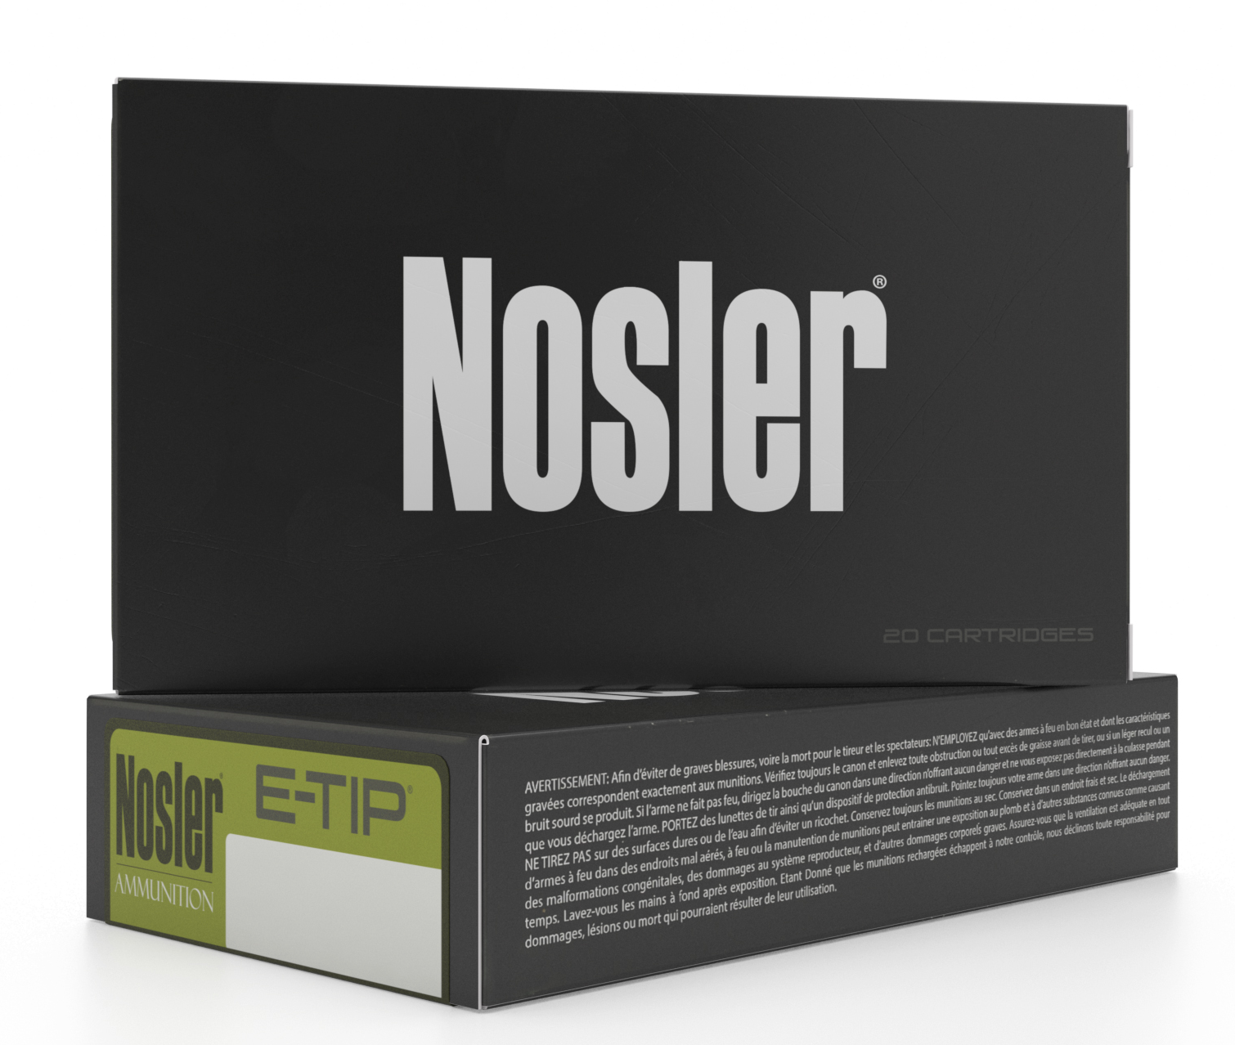
243 Winchester – 90 grain E-Tip®
270 Winchester – 130gr E-Tip®
7mm-08 Remington – 140gr E-Tip®
7mm Remington Magnum – 150gr E-Tip®
308 Winchester – 150 grain E-Tip®
308 Winchester – 168 grain E-Tip®
30-06 Springfield – 168 grain E-Tip®
30-06 Springfield – 180 grain E-Tip®
300 Winchester Magnum – 180 grain E-Tip®

For the most current information on Nosler® product announcements, visit Nosler’s Facebook page at www.facebook.com/NoslerInc

-###-

Media Contact:
Zach Waterman
Public Relations Manager
zachw@nosler.com

