NOSLER® RELOADING GUIDE 8 NOW AVAILABLE FOR PURCHASE
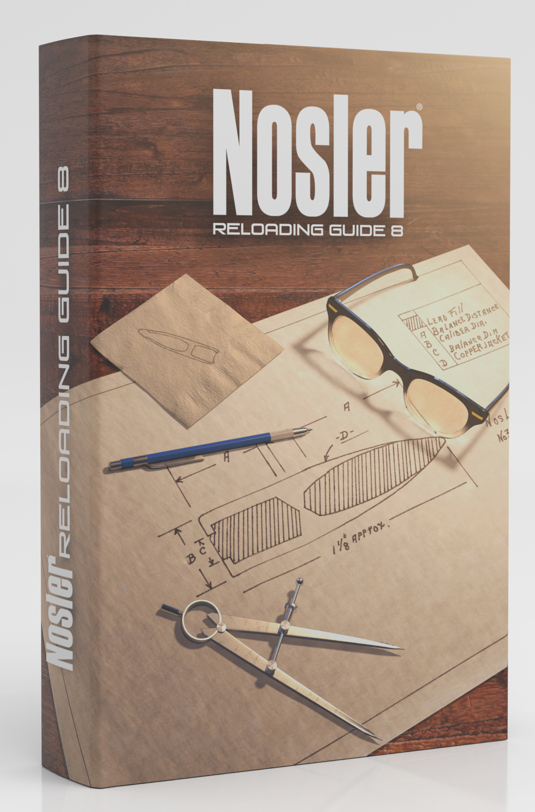
Bend, Ore. – January 14, 2016 – Nosler is proud to announce the release of their latest and most comprehensive load manual to date, Reloading Guide 8. Since their previous Reloading Guide, Nosler has introduced their AccuBond Long Range bullet line and their family of cartridges that include the 26, 28 and recently announced 30 Nosler.

Nosler Reloading Guide 8 contains 800 pages of information that features load data for nearly 120 rifle and handgun cartridges with several informative sections such as “Getting Ready to Reload” for the beginning handloader and bullet cutaways that explain Nosler bullet construction and terminal performance.

Several new and traditional powder selections have been added to many cartridges throughout the manual including Hodgdon’s new Enduron line of powders as well as Alliant’s RL26 and RL33 to name a few. In addition to new data, look for new cartridge introductions contributed by outdoor writers, Nosler ballisticians and notable individuals in the outdoor industry.

Also new for Reloading Guide #8 is subsonic load data for the 300 AAC Blackout and standard load data for the 458 SOCOM.

Nosler Reloading Guide 8 is currently available in hard copy and will soon be offered in digital format where the entire manual can be purchased for digital download.

For the most current information on Nosler® product announcements, visit Nosler’s Facebook page at www.facebook.com/NoslerInc

-###-

Media Contact:
Zach Waterman
Public Relations Manager
zachw@nosler.com

