NOSLERCUSTOM® AMMUNITION INCREASES OFFERINGS FOR 2016

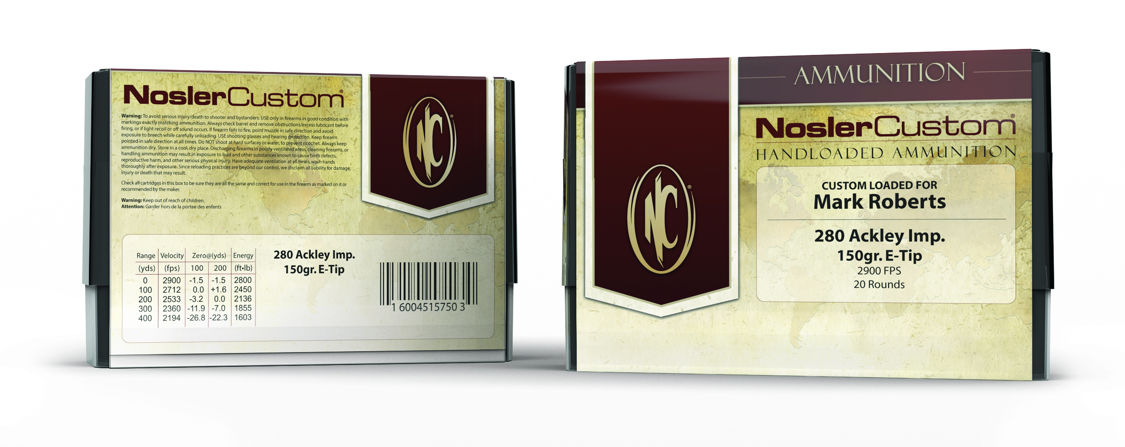
Bend, Ore – January 2016 - NoslerCustom® Ammunition is hand-loaded by Nosler’s team of expert ballisticians to ensure each and every round is perfect. There are even more options to choose from in 2016 to include:

- 270 Winchester – 130 grain Ballistic Tip®
- 30-06 Springfield – 200 grain AccuBond®
- 338 Winchester Magnum – 200 grain E-Tip®
- 340 Weatherby – 210 grain Partition®
- 35 Whelen – 200 grain AccuBond®

Using Nosler® Brass which is neck sized, deburred and chamfered for proper alignment helps ensure a solid foundation for this precise ammunition. Every powder charge is meticulously weighed guaranteeing consistent velocities and routinely checked for correct and consistent overall length. All finished rounds are then visually inspected, polished and hand packaged in hard plastic boxes with all performance data printed on the label. Ammunition box labels can also be personalized with customer’s name or information at no additional cost.

NoslerCustom® Ammunition is loaded up front with Nosler AccuBond®, Partition® and E-Tip® bullets for unrivaled accuracy and terminal performance. For the shooter who expects more; look no further than NoslerCustom® Ammunition.

For the most current information on Nosler® product announcements, visit Nosler’s Facebook page at www.facebook.com/NoslerInc
*When Available
- ### -

