Nosler® Adds New Trophy Grade® and Trophy Grade® Long Range Ammunition Offerings
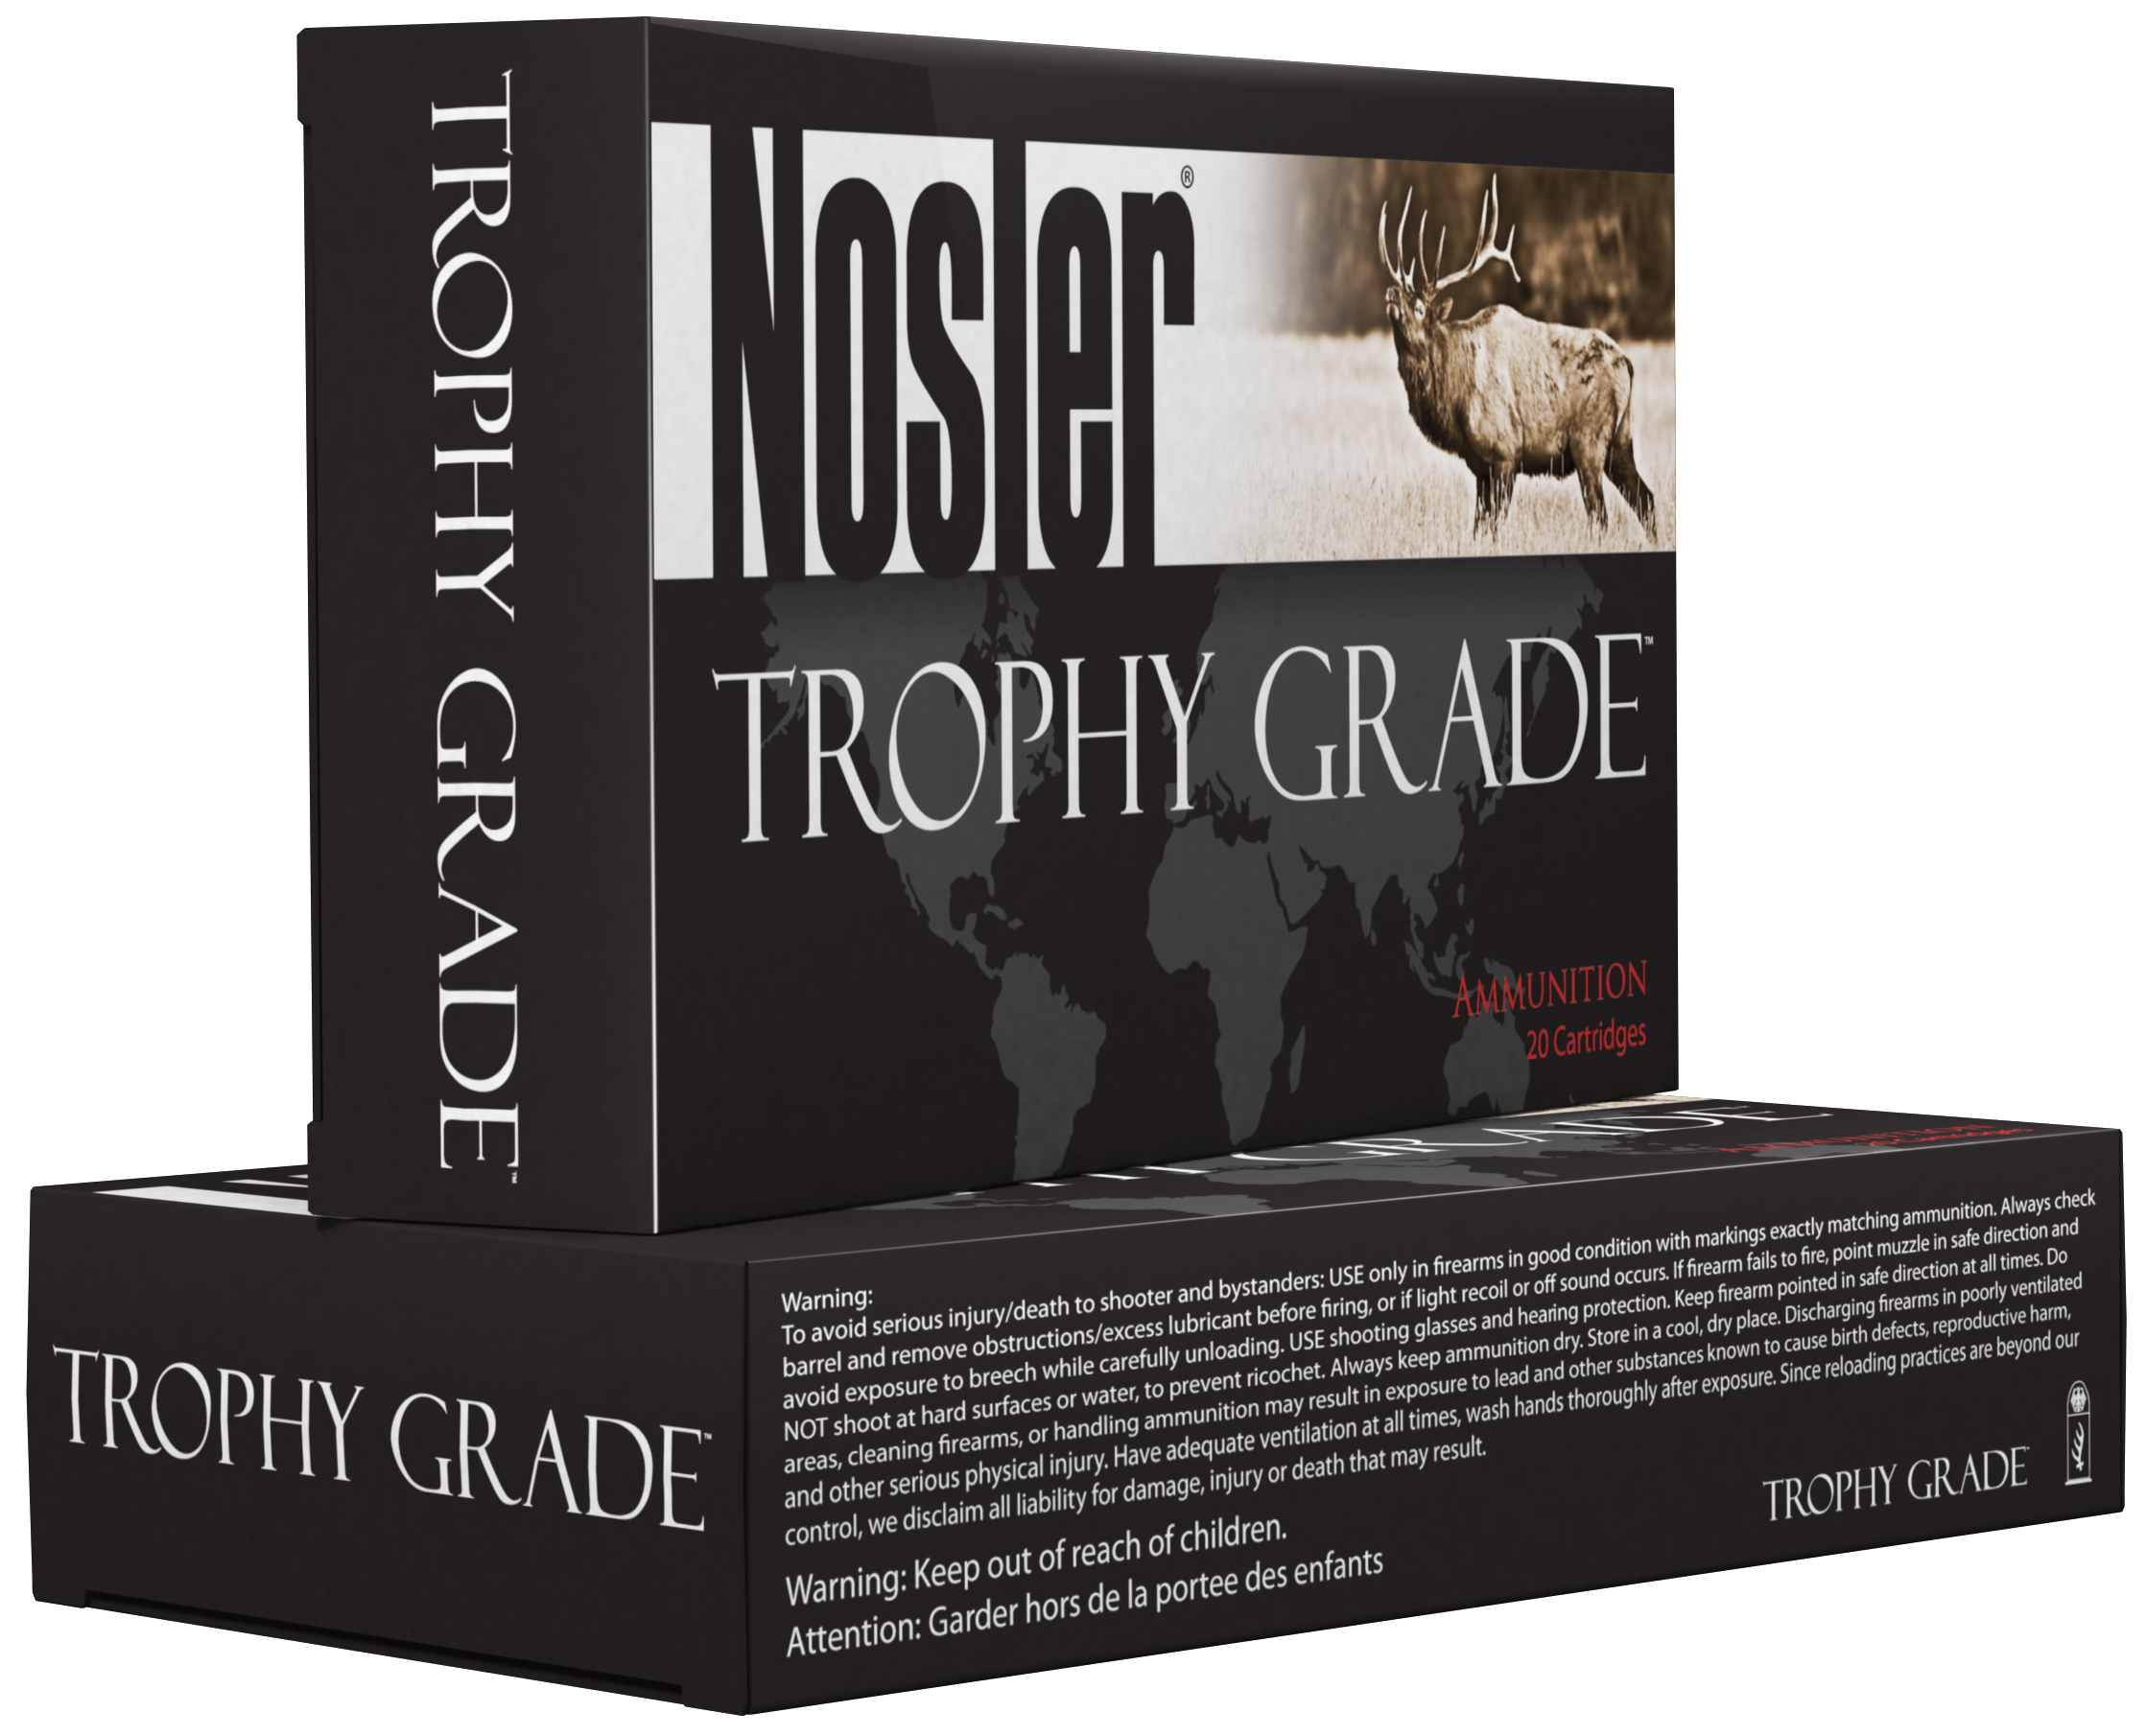
Bend, Ore. — January, 2016— Nosler’s reputation for making high quality ammunition is vastly growing among serious shooters and hunters who demand the very best. Nosler’s Trophy Grade™ and Trophy Grade™ Long Range Ammunition will add the following new offerings to the 2016 lineup:

Trophy Grade™ Ammunition:
300 Win Mag 180 grain E-Tip®
30 Nosler 180 grain AccuBond®

Trophy Grade™ Long Range Ammunition:
6.5 Creedmoor 129 grain AccuBond® LR
270 Weatherby 150-grain AccuBond® LR
30 Nosler 210 grain AccuBond® LR

For the ubiquitous 300 Win Mag, a lead free option from Nosler now exists in Trophy Grade™ ammunition. Loaded up front with the 180 grain E-Tip® at a muzzle velocity of 2950 fps and 3478 ft./lbs. of energy combined with 95% weight retention provides a devastating combo.

The Trophy Grade™ Ammunition lineup would not be complete without the addition of the new and incredibly powerful 30 Nosler® cartridge, loaded up front with the 180 grain AccuBond®. At 3200 fps and 4092 ft./lbs. of energy at the muzzle, it provides shocking external and terminal ballistics. To further compliment the introduction of the 30 Nosler cartridge, Trophy Grade™ Long Range Ammunition will also be available with a 210 grain AccuBond® Long Range loaded to 3000 fps for the ultimate in long range performance.

Also new in the Trophy Grade™ Long Range Ammunition product line expansion is a new option for the popular 6.5 Creedmoor. Loaded with the 129 grain AccuBond® Long Range bullet at 2850 fps, it delivers reliable expansion out to 1200 yards and stays supersonic past 1500 yards.

For the 270 Weatherby fans, Nosler’s Trophy Grade™ Long Range Ammunition loaded up front with the 150 grain AccuBond® Long Range bullet breathes new life into this classic by stretching the effective range well past 1,000 yards.

For the most current information on Nosler® product announcements, visit Nosler’s Facebook page at www.facebook.com/NoslerInc
-###-

